**Problem 1**

Let X be a random variable that takes nonnegative integer values, and is associated with a transform of the form 𝑥(𝑠)= $k\frac{(9+6e^{s}+1e^{2s})}{3-2e^{s}}$ Find $E[X|X≠1,2]$

**Answer 1**

1. 𝑀𝑥(0) = E[1]=1 , so k=1/16
2. Since X only take nonnegative integer values ：

𝑀(𝑠) = px(0) $e^{0}$ +px(1) $e^{s}$ + px(2) $e^{2s}$…… and so on

Use long division, we know 𝑀(𝑠)= $\frac{1}{16}(3+4e^{s}+3e^{2s}+2e^{3s}……..)$

thus we know px(0)=3/16 px(1)=4/16 px(2)=3/16 …

1. Now use total expectation theorem:

E[X]=E[X|X=1]P(X=1)+E[X|X=2]P(X=2)+ $E[X|X≠1,2]$ P($X≠1,2$)

Where E[X]= $\frac{d}{ds}Mx\left(s\right)|s=0$ = $\frac{5}{2}$ and P($X≠1,2$)= 1-P(X=1,2)

So $\frac{5}{2}$ = 1 $\frac{4}{16}$* + 2 $\frac{3}{16}$* + $E[X|X≠1,2]$ (1- $\frac{7}{16}$)

Thus $E[X|X≠1,2]$ = $\frac{10}{3}$

**Problem 2**

A vendor machine supplies **‘n’** different types of beverages, and it is visited by a number **Y** of customers in a certain period of time, we know that X is a nonnegative integer random variable with known transform $M_{Y}\left(s\right)=E[e^{sY}]$. Each customer will buy one single beverage, with all types of beverage being equally likely, independent of the number or the types other customers buy. Please derive the formula in terms of $M_{Y}\left(.\right)$ for the **expected value** of **number of different beverage** ordered.

**Answer 2**

Let’s first define a random variable X:

$X_{i}\left\{\begin{aligned}1, if type i beverage is ordered by customers at least once \\ 0, otherwise\end{aligned}\right.$

Then X = X1+X2+X3…..+Xn, X means number of different drinks ordered.

Using Law of Iterated Expectaiton:

$E\left[X\right]= E\left[E\left[X | Y\right]\right]=E\left[E\left[X1+X2….+Xn | Y\right]\right]=nE[E[Xi|Y]]$

Now, we know the beverage not be ordered by probability p = (n-1)/n

Then, the expected probability of it being ordered at least once is:

$E\left[X_{1} | Y=y\right]= 1-{(\frac{n-1}{n})}^{y}$

So, we can know $E\left[X_{1} | Y\right]= 1-{(\frac{n-1}{n})}^{Y}$

Lastly, $E\left[X\right]=nE\left[1-p^{Y}\right]=n-nE\left[p^{Y}\right]=n-nE\left[e^{Ylogp}\right]=n-nM_{Y}(logp)$

**Problem 3**

Suppose that X and Y are random variable with the same variance. Show that X-Y and X+Y are uncorrelated?

**Answer 3**

Because the covariance remains unchanged when we add a constant to a random variable, we can assume without loss of generality that X and Y have zero mean. We then have

Cov(X-Y , X+Y) = E[(X-Y)(X+Y)] = E[$x^{2}$] - E[$y^{2}$] = 0

since X and Y were assumed to have the same variance.

**Problem 4**

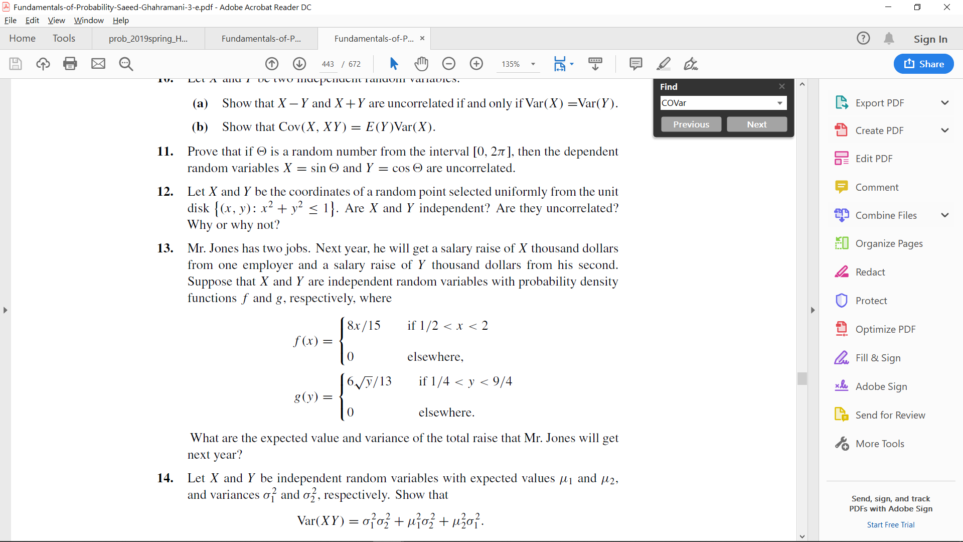

**Answer 4**

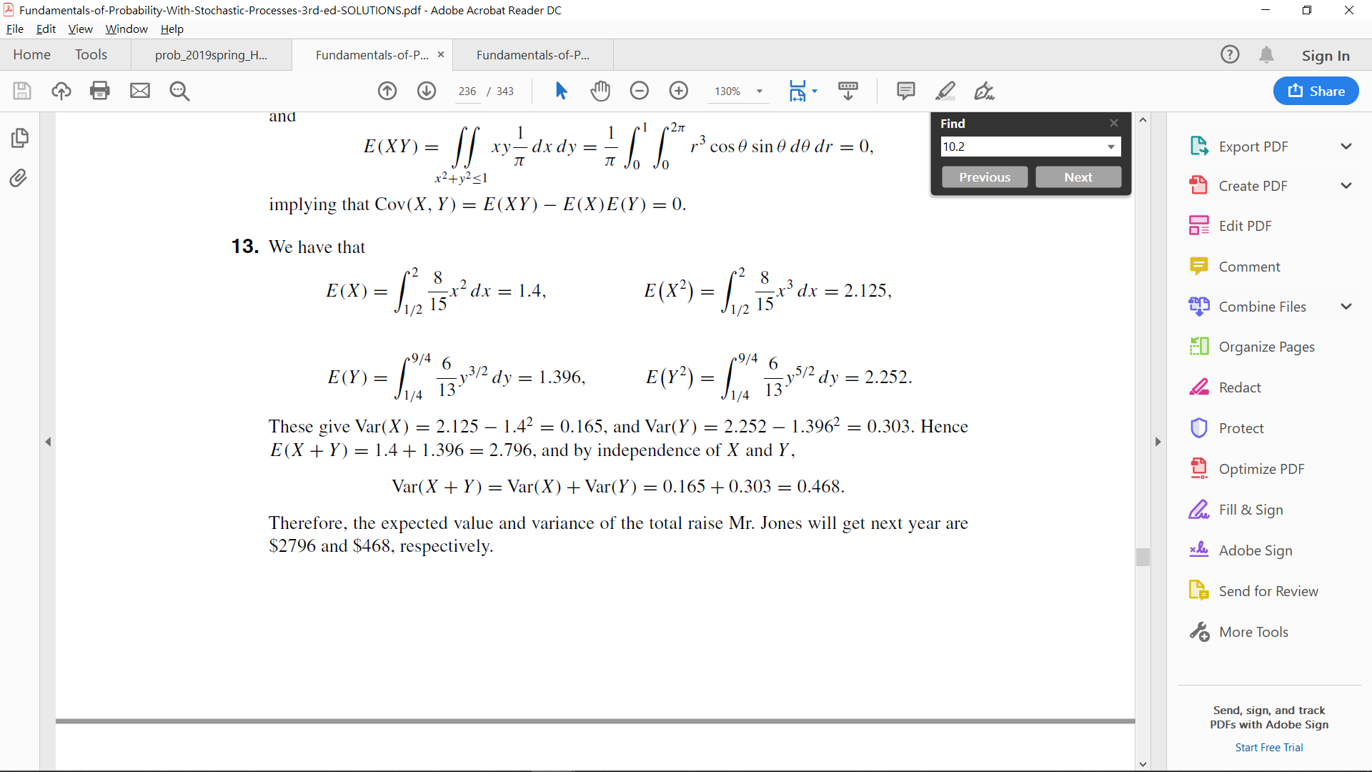

**Problem 5**

A coin with probability p of heads is tossed until the first head occurs. It is then tossed again until the first tail occurs. Let X be the total number of tosses required.

(i) Find the distribution function of X. (ii) Find the mean and variance of X.

**Answer 5**

